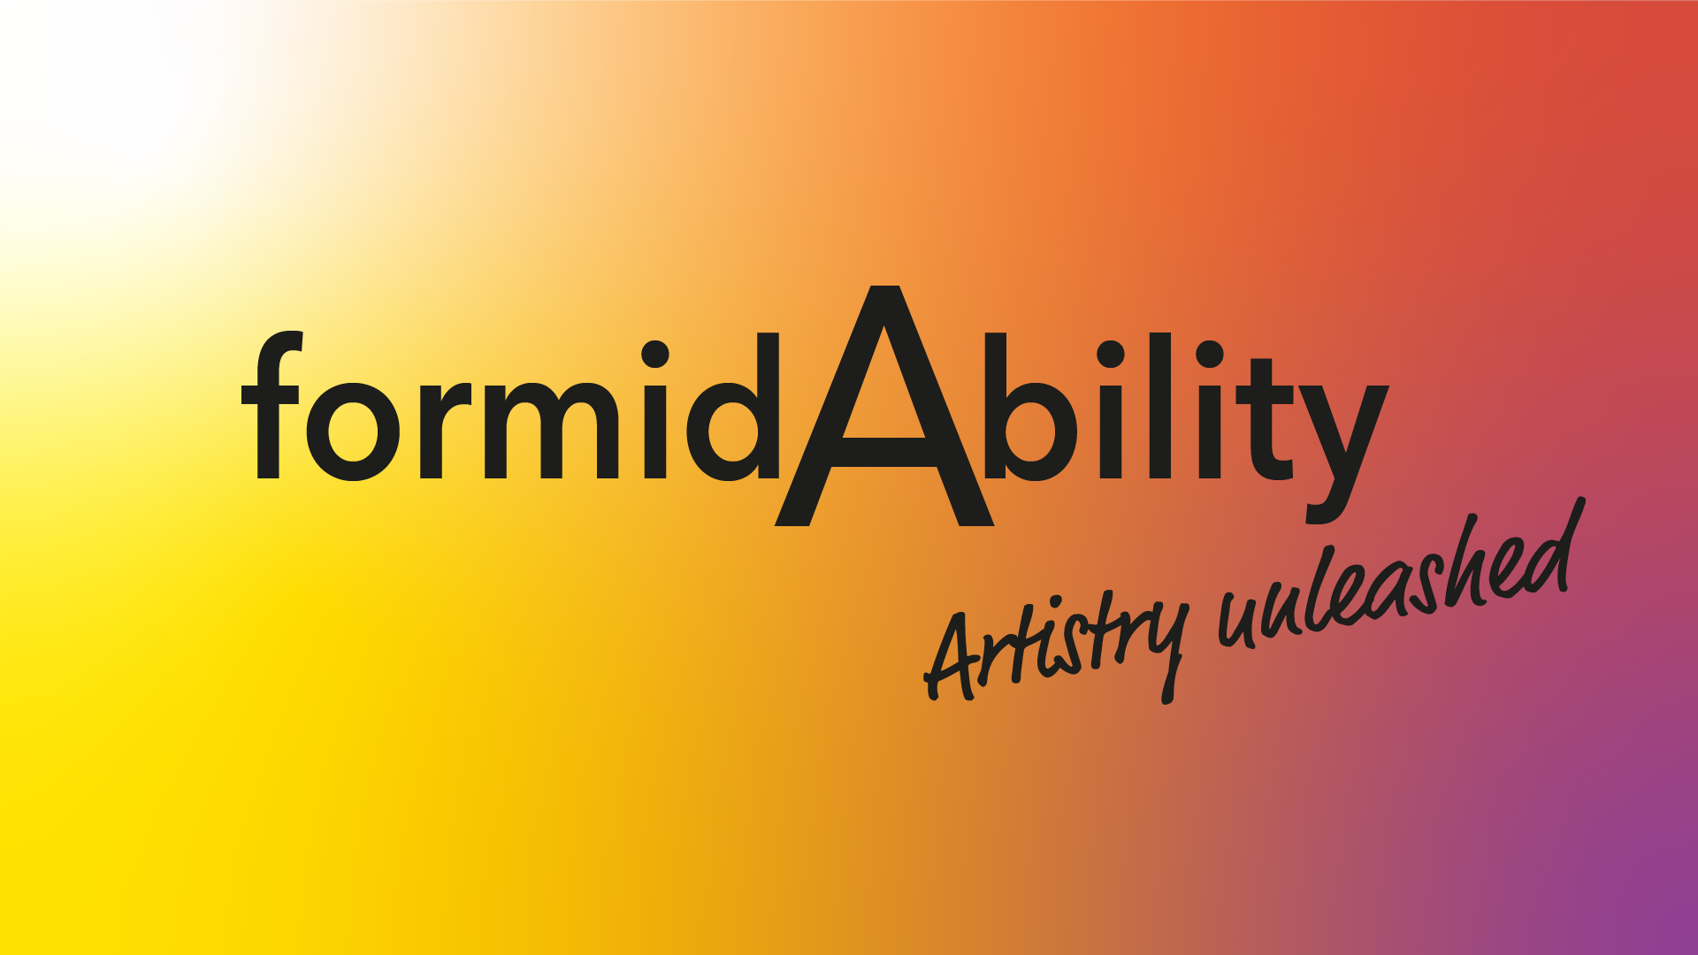

formidAbility Board Recruitment Pack

https://www.formidability.org

About formidAbility
formidAbility is the UK’s only majority disability-led opera company. Our trailblazing work putting accessibility at the heart of the creative process is attracting interest from a number of major arts organisations. Inspired by her work singing with Paraorchestra and her experience as a sight-impaired opera singer, Joanne Roughton-Arnold (soprano) joined with Holly Mathieson (conductor) to found the company in 2019. The passionate belief that opera has the potential to reach many more people if we better reflect the diversity of the general public is at the core of the company’s work. Nearly one in four people in the UK identify as disabled, but we don’t see anywhere near that number on stage, in creative teams or in opera company governance.

We seek to lead by example: engaging a mix of disabled and non-disabled professional artists to create powerful work of the highest calibre that speaks to as wide a demographic as possible, weaving accessibility for our audiences throughout our productions. We believe that by placing accessibility front and centre and giving it artistic life of its own, we enrich the experience of all artists and audiences, breaking down barriers and challenging perceptions about disability and inclusion in the arts. We choose not to make work focusing solely on disability; this would risk ghettoising disabled artists & audiences. Instead, we make art for everyone, raising the profile of disabled artists to the wider profession and shining a light on the talent and skills that have gone unnoticed for far too long.

Our work so far

2015-17 Iris Dreaming
In 2015 with support from Creative New Zealand, Joanne commissioned Iris Dreaming from Dame Gillian Whitehead and Fleur Adcock CNZM OBE. She produced and performed the world premiere as part of the 2016 Grimeborn Festival at London’s Arcola Theatre, followed by the New Zealand premiere at the 2017 Adam Chamber Music Festival.

This was Joanne’s first foray into producing and commissioning new work, setting her on the path that would eventually lead to the founding of formidAbility.

2019: Hotspur / Pierrot Lunaire
formidAbility’s first production was created in collaboration with Signdance Collective International. This was a double-bill pairing Hotspur by Dame Gillian Whitehead and Fleur Adcock CNZM OBE with Schoenberg’s iconic Pierrot Lunaire in a world-first merging of opera and signdance.

Imaginative live audio description from leading practitioners Rationale Method, pre-concert touch tours and braille translations for the audience were also incorporated into the production.

2020: The Bridge Between Breaths
A COVID Emergency Grant from Arts Council England enabled formidAbility to continue creating during 2020. We commissioned Gareth Churchill and Hafsah Aneela Bashir to write a new opera that reflected something of the challenging times we were all living through at the start of the pandemic. The Bridge Between Breaths, centred around the felling of Colston’s statue, was the result.

We held five days of research and development to explore the new work and how we might use visual art to make opera more accessible for D/deaf audiences. Our work was broadcast online as part of 2020 Tête à Tête: The Opera Festival.

2021: Time to reflect
As a very new company, formidAbility wasn’t eligible to apply to the Culture Recovery Fund, so the second year of the pandemic was a quiet one for us. However this created time and space for a valuable period of reflection and planning, laying the groundwork for prudent organisational development and putting us in a good position to move forward post-pandemic with new creative projects and partners.

Conversations with other arts organisations throughout 2021 met with enthusiasm for our work to date and an interest in developing potential partnerships. In the autumn, Joanne was one of six mentees selected for the pilot 3-month long Engender x We.Grow mentoring scheme, focusing on the intersectionality of her roles as freelance opera singer and Creative Director of formidAbility, and how they combine to strengthen her advocacy for inclusion in the opera industry. Building on our relationship with Arts Council England, the clear alignment of our company ethos with ACE’s “Let’s Create” strategy makes it plain that with the right support formidAbility is in prime position to take its place front and centre of the movement for greater inclusion in the arts.

Current project and future planning

2022-2024: Song in Sign
Song in Sign is part of our mission to bring high quality disability-led creativity to mainstream audiences, trailblazing the way for long-term inclusion across the sector and showing what can be achieved when barriers are removed. Two singers, a pianist and two Deaf actors collaborate as equals in a visual expression of music through BSL, staging and lighting, the phrasing of song and sign synchronised as intense communication between actors, musicians and audience to create a merging of art forms that spans the D/deaf and hearing experiences. The Project is divided into two phases:

Phase One: April - August 2022
We commissioned a new 15-minute work for two singers, pianist and two Deaf actors based on Oscar Wilde’s The Happy Prince. Max Chase adapted the text and Rylan Gleave composed the music, embedding BSL into the musical score. We held six days of research and development in July 2022 to work on The Happy Prince and explored new ways of collaborating across art forms, culminating in an informal sharing of our work for invited industry guests. This phase also included organisational and professional development to support our creative work.

Phase Two: 2023-2024
In Phase Two we will prepare and deliver a tour to four of the UK’s leading conservatoires, using high profile venues to shine a light on disabled talent and encourage aspiration among people who rarely see themselves reflected on mainstream stages. We will work with our venues to open their spaces to new audiences, using our lived experience to ensure that access needs are met and disabled audiences feel welcome. Our project includes wrap-around visits and workshops for the local D/deaf and disabled communities.

All venues have confirmed financial arrangements and dates in early 2024 (subject to funding). Each venue will host a two-day visit to include:

- A public concert in celebration of diversity with Rylan Gleave’s new work at the heart of the programme. The entire concert will be signed by our two actors, collaborating as equals with singers and pianist in an embodiment of our ethos of creative accessibility.
- A workshop given by our team of artists for students at each conservatoire to share our approach to creative inclusion, influencing their attitudes towards disabled artists and audiences and contributing to long-term sector change.

Art Song (working title)
We plan to move on to this new project after the completion of Song in Sign, shifting our focus to visually impaired audiences and turning audio description into the main event.

Who we’d like to join us
We are looking for up to three individuals with a passion for inclusion and a desire to contribute to arts-based social change. We want to build a team of people with the passion and experience to help an arts organisation in its formative years embed in the UK arts ecosystem and scale-up in a prudent and lasting way.

In line with our primary artistic mission, we want our board to reflect the diversity and inclusion we work so hard to present onstage. We would be excited to receive applications from people from communities currently underrepresented in the opera industry, especially those identifying as D/deaf or disabled, LGBTQI+ and people from the Global Majority. Please let us know how we can facilitate your application or attendance, any access requirements you have, or if you are concerned that something impedes your capacity to apply. We will do everything we can to mitigate the issues and welcome you to the organisation.

While we welcome expressions of interest from people with creative backgrounds, it is not a prerequisite, but we do hope you will have one of the following skills to help govern the next stage of our development:

- Fundraising and funding applications
- Arts strategy and planning
- Fiscal governance
- Legal compliance
- Branding, marketing and audience development

The successful candidate(s) will

- Play a full role as a Board Director in deciding the company’s strategy and overseeing its implementation, promoting its activities and safeguarding its reputation;
- Sit on sub-committees, as necessary;
- Ensure the organisation’s activities are compliant with financial and legal obligations;
- Advise the Creative Director and staff on their short and long-term financial strategy;
- Help to promote the company, growing its network within the opera industry and beyond;
- Participate in negotiations with the Musicians’ Union and Equity, and advise us of current best practice for freelance recruitment and contracting;
- Regularly review the policies of the organisation, including Safeguarding, Sustainability and Equalities;
- Help us to scale the organisation while retaining our core values and commitment to excellent art.

Term
Directors serve on a rotational basis. According to our Articles of Association, at every Annual General Meeting one third of the Board of Directors must retire, the longest serving retiring first. However, any retiring member of the Board of Directors may immediately stand for re-election. Whilst we are primarily looking for Directors to serve for at least 3 years, we would be open to discussing a shorter term for anyone who feels they can add value to the company but who cannot make a longer term commitment.

Remuneration
This is an unpaid voluntary position, but expenses such as childcare, travel or personal access costs will be paid upon presentation of receipts.

Location
Online with a planned in-person annual Away Day (venue to be confirmed)

Time Commitment
- Four Board Meetings a year, one of which is our Annual General Meeting.
- Maintain a presence at performances and Research and Development events, as your time and circumstances allow.

Induction, support and training
You do not need to have prior board or executive experience – we will provide a full induction to the Board’s activities and Director training on appointment, as required.

We view the welcoming of new Directors to our Board as an opportunity to train and induct all Board members so that we can create an inclusive, dynamic and effective board to take formidAbility forward and grow into its potential to be a trailblazing example to the opera profession.

We’ll meet with you (online or in person) to discuss what training and support you would like in order to fulfil your role effectively, and what type of development opportunities the board might undertake together.

Shortlisted candidates will be invited to attend a Board meeting in an advisory capacity (without voting rights) before making a formal commitment.

How to apply
Please send a CV and covering letter (no more than two sides of A4) or a video (no more than 5 minutes duration) telling us why you’d like to join us as a Director and what skills and experience you could bring to our organisation. Please bear in mind that our Creative Director is partially sighted, so sending material in an accessible format would be appreciated (sans serif font, at least 14pts with 1.5 spacing).

We’d love to hear about
- Why our work and being a Director of formidAbility interests you
- What you think you could bring to the role of Director
- What your passions are and what inspires you

Please send your application to joanne@formidability.org with Director Application in the subject line. Please also let us know of any access requirements that you may have.

Please complete our Equal Opportunities Monitoring form here

We are open to receiving applications in an alternative format if the formats suggested above aren’t accessible to you.

We will aim to acknowledge receipt of your application within 5 working days and to inform you of the outcome of your application within 30 days. If we feel you are a suitable candidate we will invite you for an informal interview with one or more existing board members at a mutually agreeable time (online or in person).

If you would like an informal chat with a current board member before applying, we are happy to facilitate this. This can be online, on the phone or in person. Please email joanne@formidability.org to express your interest.

The legal bit

What it means to be a director:
As formidAbility is a non-profit Company Limited by Guarantee, anyone wishing to be a Company Director must first join formidAbility as a Company Member. All Company Members guarantee to contribute up to one pound to the assets of the Company, should it be wound up while they are a Member or within one year after they cease to be a Member.

A director must be 16 or over and not be disqualified from being a director. Directors’ names and personal information are publicly available from Companies House.

Learn more about a director’s responsibilities and who can be a director at www.gov.uk/running-a-limited-company

